3. Azure Blob Storage
Azure Blob Storage is Microsoft’s cloud-based service designed to store large amounts of data of various types — including structured, semi-structured, and unstructured data.
It is ideal for storing files such as CSV, text, Excel, JSON, Parquet, Avro, XML, images, videos, backups, and logs.
The term “Blob” stands for Binary Large Object, meaning it can store any type of binary data. Blob Storage provides a flat namespace, meaning all files (blobs) are stored in containers within a storage account, rather than in a traditional hierarchical folder system.
Azure Blob Storage is highly scalable, secure, and cost-efficient, making it suitable for:
- Storing and serving large files (media, documents, etc.)
- Data lakes and analytics workloads
- Backup and disaster recovery
- Archiving and compliance storage

3.1 Create an Azure Blob Storage:
Go to Azure Portal
In the search bar, type “Storage Accounts” or “blob”
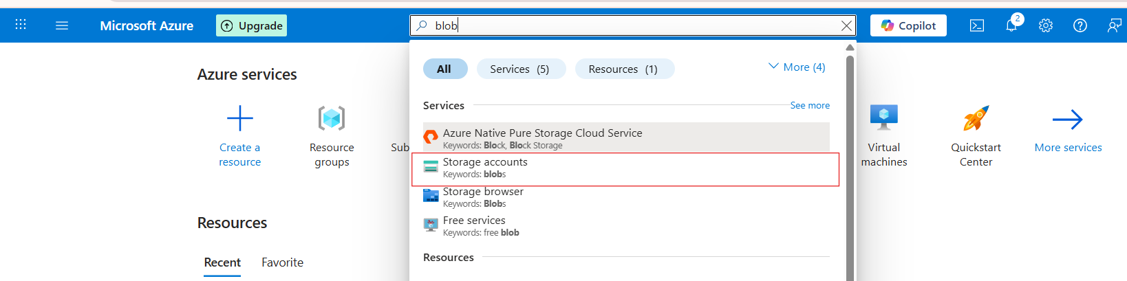

Click on storage accounts and click on create button
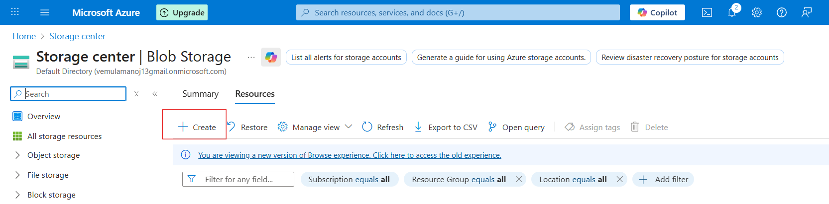

Click “Review + Create”
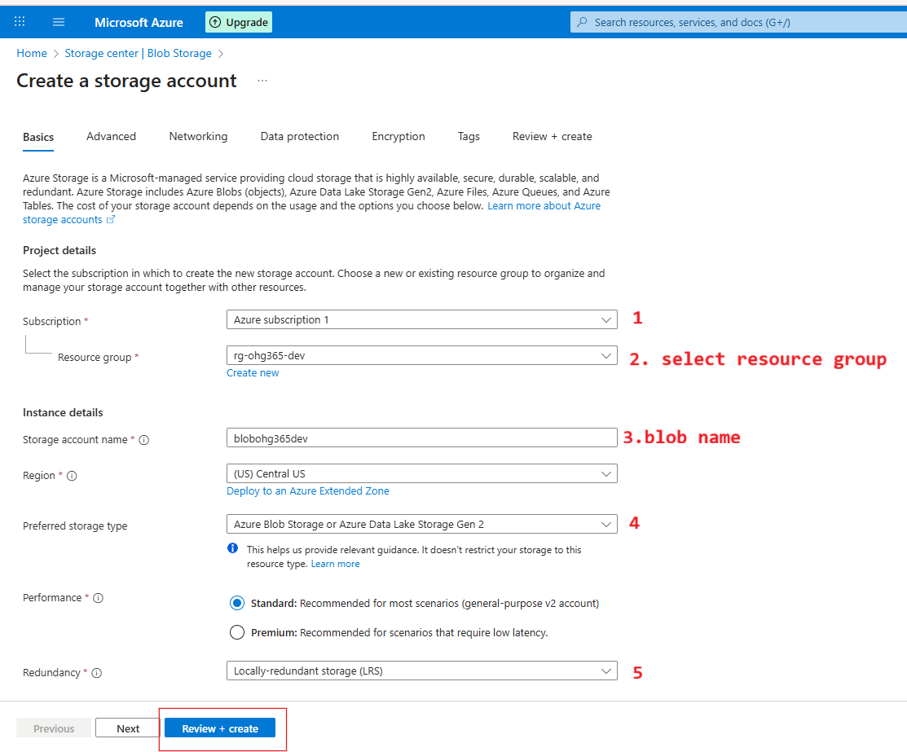

1️⃣ Subscription
- This is where you choose which Azure Subscription will own this storage account.
- A subscription is linked to your billing and access control.
- Example: You might have separate subscriptions for development, testing, or production environments.
🟦 You selected: Azure subscription 1

2️⃣ Resource Group
- Choose or create a Resource Group to organize related Azure resources.
- Resource Groups act like folders — all your related resources (VMs, storage, databases) are stored here for easy management.
- In your case, you selected rg-ohg365-dev, which is perfect for development resources.
🟦 Tip: Keeping related resources in the same group helps you track cost, permissions, and manage everything easily.
3️⃣ Storage Account Name
- This is the unique name for your storage account (like a domain name).
- It must be globally unique, lowercase, and 3–24 characters long.
- This name will form part of the URL to access your data.
🧩 Example:
If your name is blobohg365dev

4️⃣ Preferred Storage Type
- Select what kind of storage service you want to enable.
- The default (and most common) option is:
Azure Blob Storage or Azure Data Lake Storage Gen2
🧠 This means your account will support:
- Blob storage (for files, media, etc.)
- Data Lake capabilities (for analytics and big data processing)
🟦 Tip: Keep this as default unless you have a specific need for file shares or queue services.

5️⃣ Performance & Redundancy Settings
⚙️ Performance:
- Standard: Uses HDD-based storage — cheaper, good for general use.
- Premium: Uses SSD-based storage — faster, ideal for workloads needing low latency (like databases or VMs).
🟦 You selected: Standard (recommended)

🧭 Redundancy:
Defines how Azure will replicate your data to keep it safe.
Option | Meaning | Copies of Data
LRS (Locally-redundant storage) | Keeps 3 copies in one data center | 3
ZRS (Zone-redundant storage) | Copies across 3 availability zones in the same region | 3
GRS (Geo-redundant storage) | Copies data to another region (for disaster recovery) | 6
RA-GRS (Read-access Geo-redundant) | Same as GRS but allows read access to secondary region | 6
🟦 You selected: LRS (best for development/testing)

Click on create
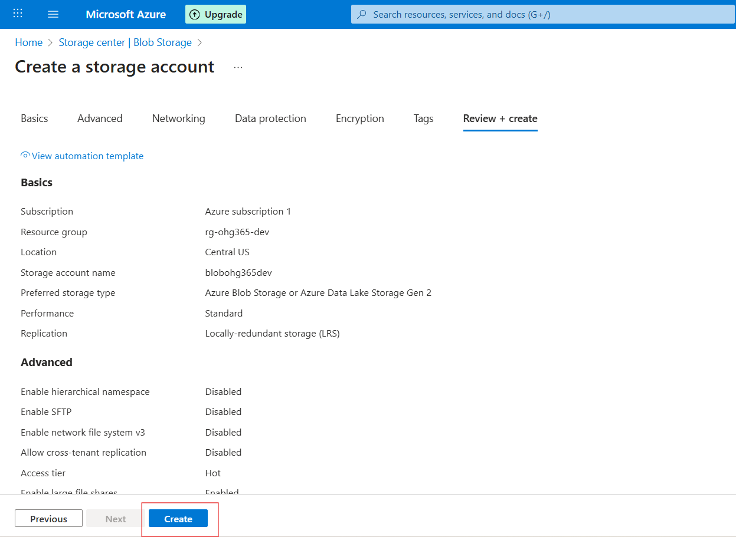

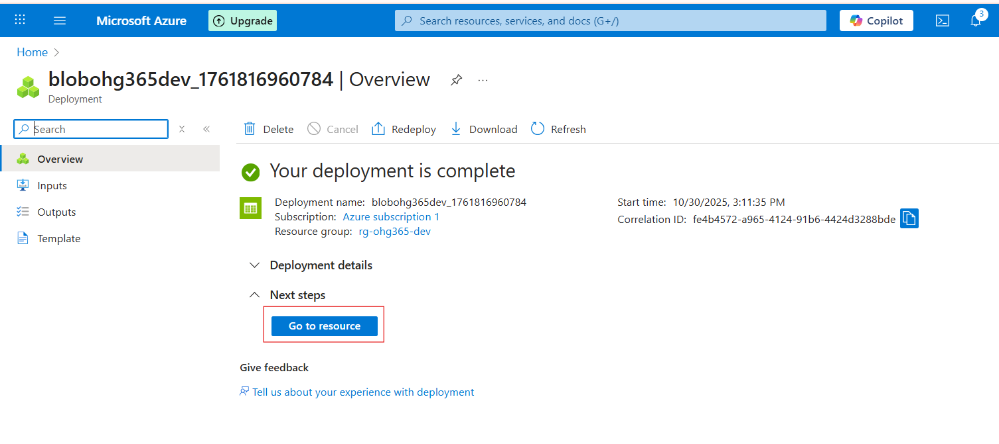
Navigate to Your Resource Group
- In the left-hand menu, click on Resource groups
- Find and click your resource group — in your case:
👉 rg-ohg365-dev
- Check for the Storage Account
- Inside the Overview tab of your resource group, you’ll see a list of all resources.
- Look for an item that looks like this:
Type: Storage account
Name: blobohg365dev (or whatever name you used)
If it appears there, 🎉 congratulations — your Blob Storage account has been successfully created
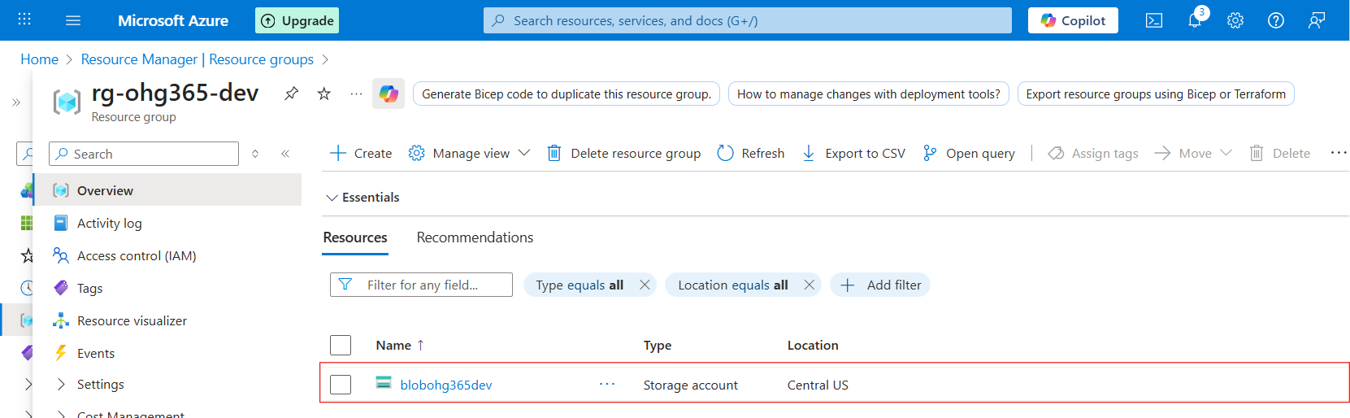

3.2 Types of Azure Storage Services:
Azure Storage provides four main types of services under one Storage Account.

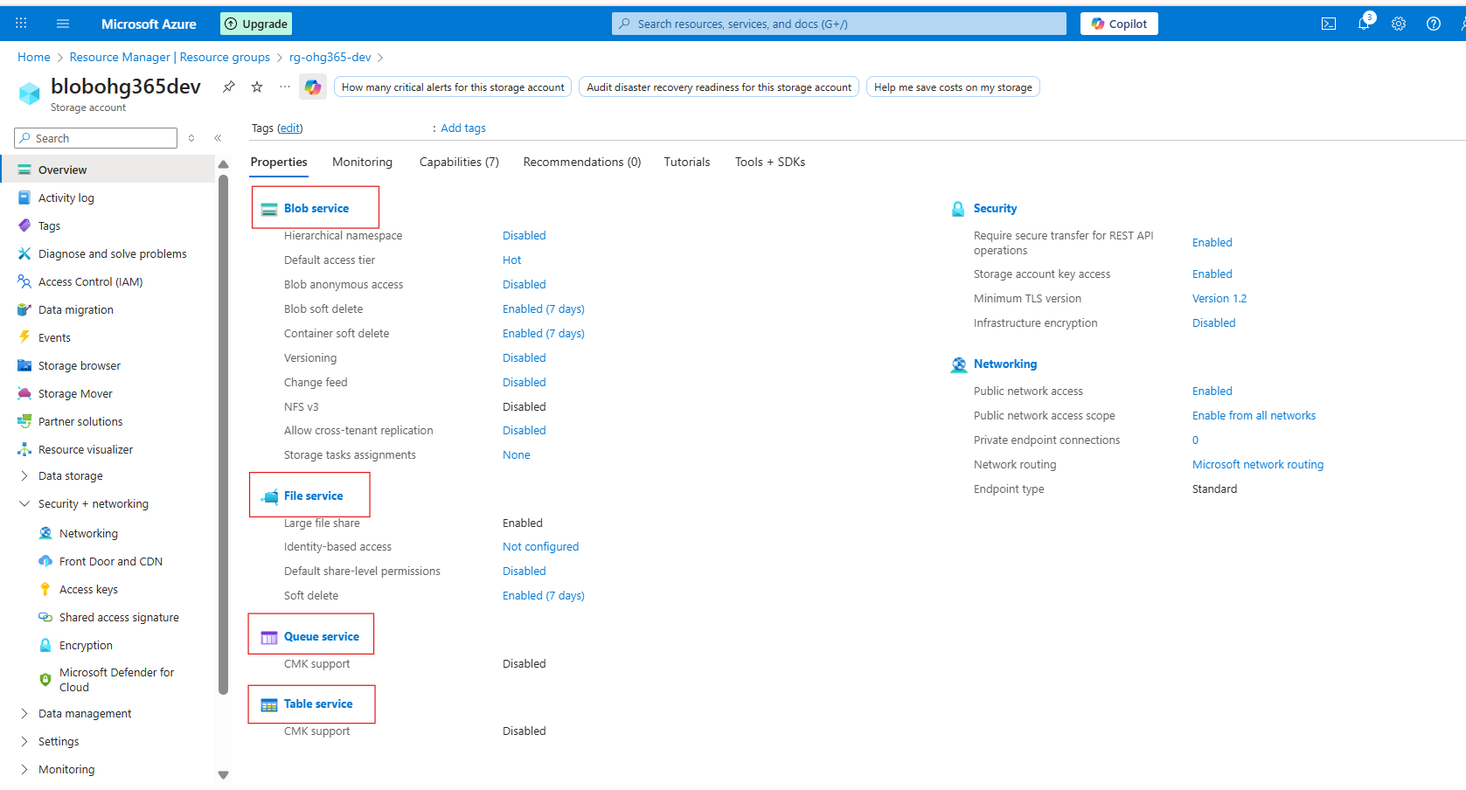

1️⃣ Blob Service
🧱 Used to store unstructured or semi-structured data like files, images, videos, logs, and backups.
🔹 Description:
- Stores data as Blobs (Binary Large Objects) inside containers.
- Best for storing flat files and large objects that don’t fit in a database.
- Data can be text, binary, documents, media, or backups.
💾 Example Uses:
- Storing images or videos for websites
- Backups and archives
- Data lake for analytics
- Hosting static websites
📦 Example File Types:
.txt, .csv, .json, .xml, .jpg, .mp4, .zip, .bak

2️⃣ File Service
📁 Used for shared file storage that behaves like a traditional file server.
🔹 Description:
- Provides Azure Files, a fully managed file share in the cloud.
- Uses the SMB (Server Message Block) or NFS (Network File System) protocols — the same used by on-premises file servers.
- Can be mounted to Windows, Linux, or macOS systems.
💾 Example Uses:
- Shared network drives for teams
- “Lift and shift” of on-premises file servers
- Application configurations shared across multiple VMs
📦 Example Scenario:
You have multiple virtual machines needing access to the same configuration files — you can store those files in Azure Files and mount them just like a shared folder.

3️⃣ Queue Service
📬 Used for reliable messaging between application components.
🔹 Description:
- Provides asynchronous communication between services using message queues.
- Stores messages in a queue, which can be processed later by background services or workers.
- Ensures messages are delivered at least once and processed in FIFO (First-In, First-Out) order.
💾 Example Uses:
- Sending background jobs (like image processing or email sending)
- Decoupling app components for scalability
- Event-driven architecture
📦 Example Scenario:
A web app uploads an image → sends a message to a queue → a background process picks it up and resizes the image.

4️⃣ Table Service
🧮 Used to store large amounts of structured, non-relational data.
🔹 Description:
- Provides NoSQL key-value storage.
- Stores data in tables with entities (rows) and properties (columns).
- Flexible schema — you can add or remove columns anytime.
💾 Example Uses:
- Storing user profiles, IoT data, or metadata
- Fast lookups by key
- Lightweight applications needing scalable, cheap storage
📦 Example Scenario:
You have millions of IoT sensors sending temperature data — you can store this efficiently in Azure Table Storage.

🧠 Summary Table
Storage Service | Type of Data | Description | Example Use Case
Blob Service | Unstructured / Semi-structured | Stores large objects (files, media, backups) | Images, videos, logs
File Service | File-based | Shared file storage via SMB/NFS | Shared drives, app configs
Queue Service | Messaging | Message-based communication between components | Background tasks, event processing
Table Service | Structured (NoSQL) | Key-value, schema-less table storage | User profiles, IoT data

Explore Blob Service
Once your storage account is created:
- Go to your Storage Account
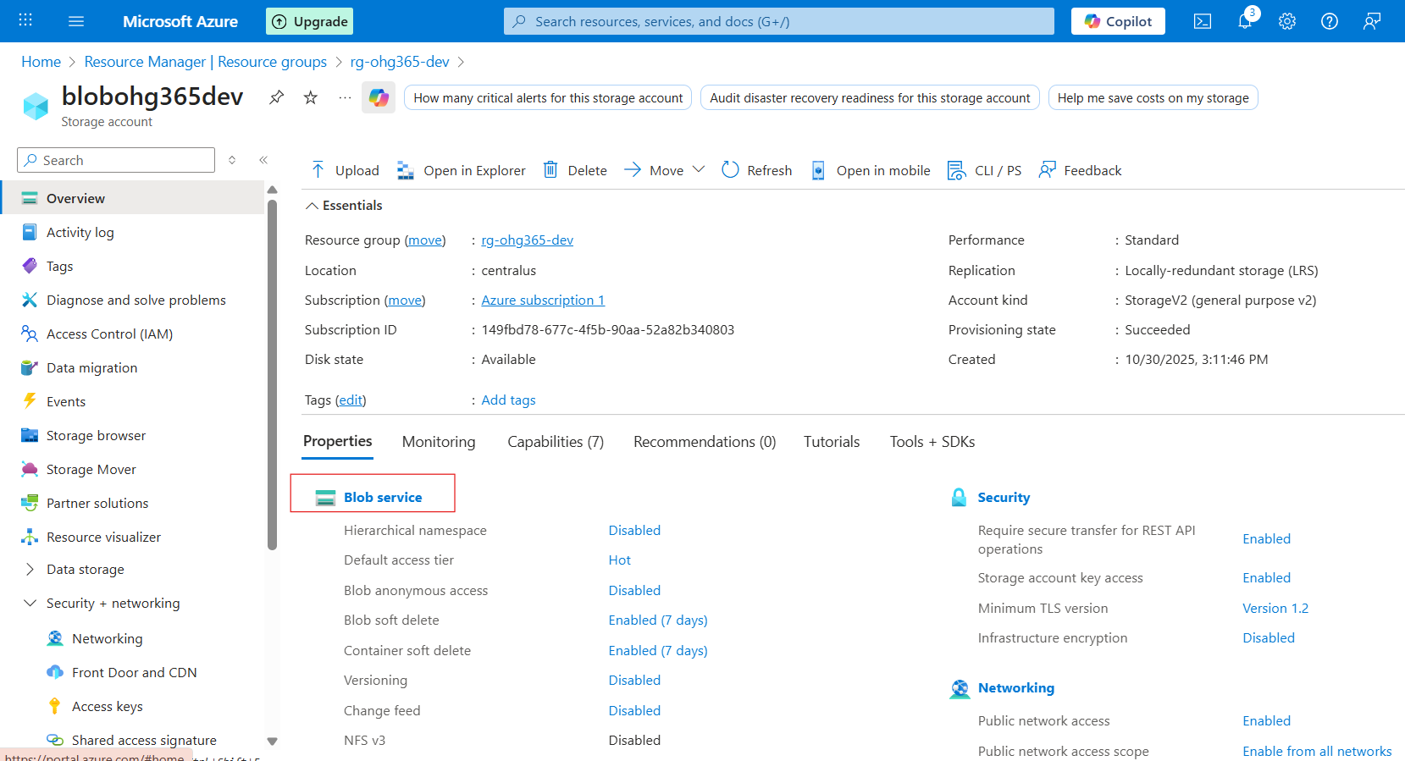

- Under Data storage, click Containers → This is where your blobs live.
- Click ➕ Container to create one:
  - Name: images, videos, or backups (any name)
  - Public access level:
    - Private (default) – Only you can access
    - Blob (anonymous read) – Anyone with the link can read blobs
    - Container (public) – Everyone can see contents
  - Click Create
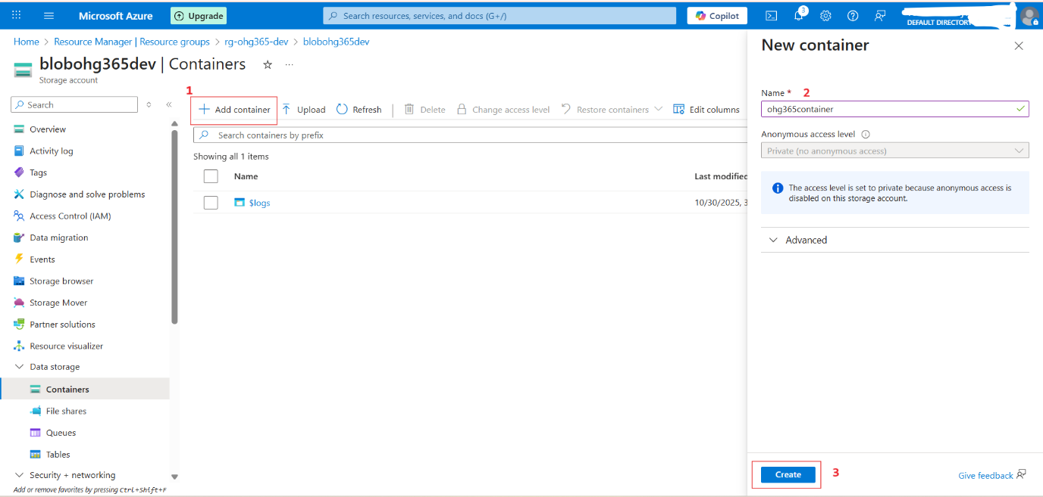

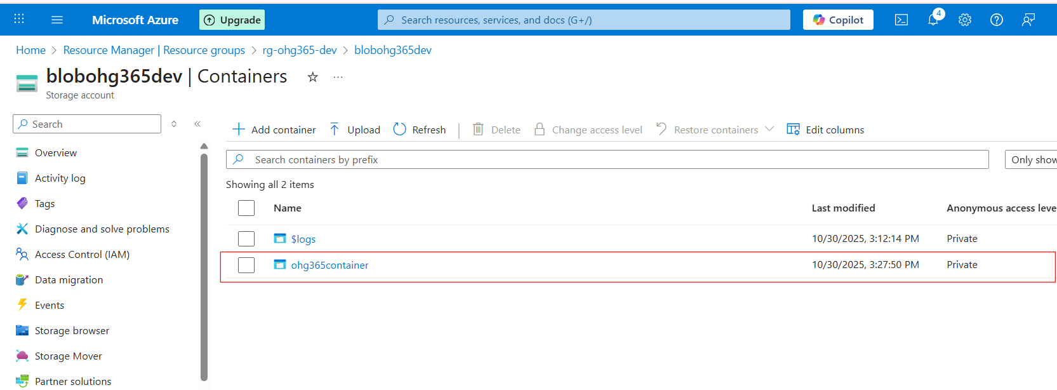

Upload & Manage Blobs
- Click your new container (e.g., images)
- Click Upload
- Choose a file from your computer (like a .jpg, .txt, or .mp4)
- Once uploaded, you can:
  - View Properties (size, type, last modified)
  - Get the URL to access the file
  - Change the access tier

Storage Account
└── Blob Service
└── Container (like a folder)
└── Blob (the actual file)
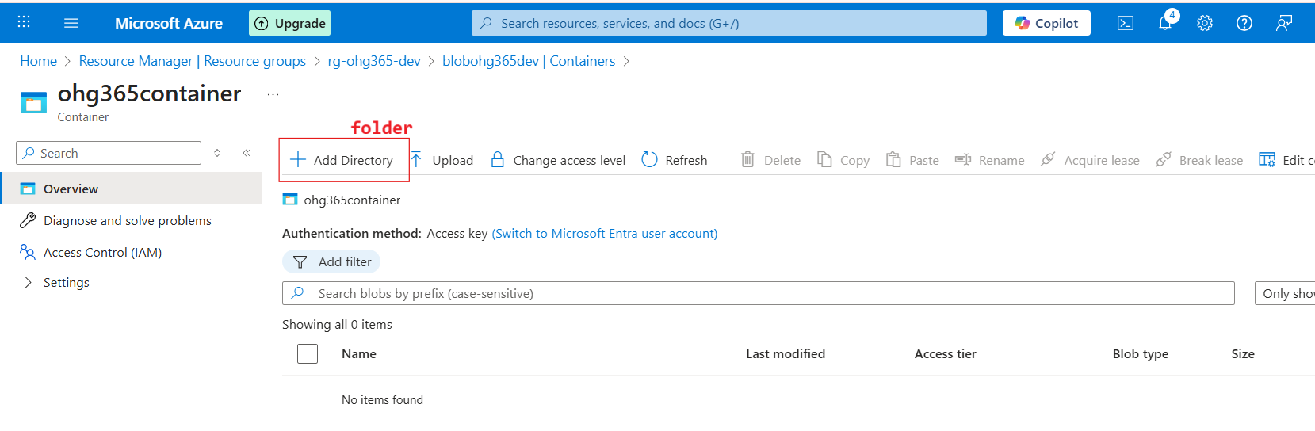

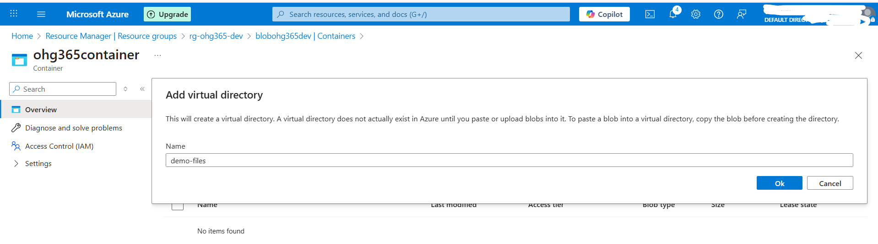
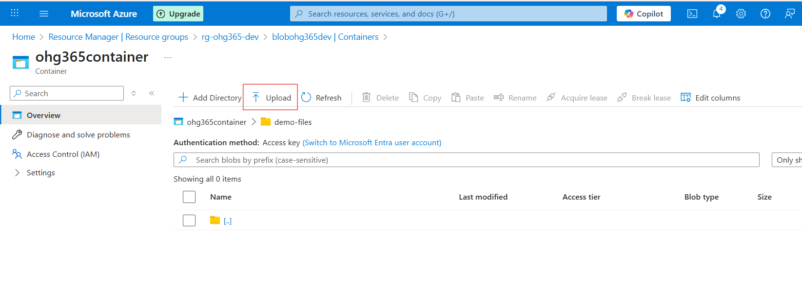
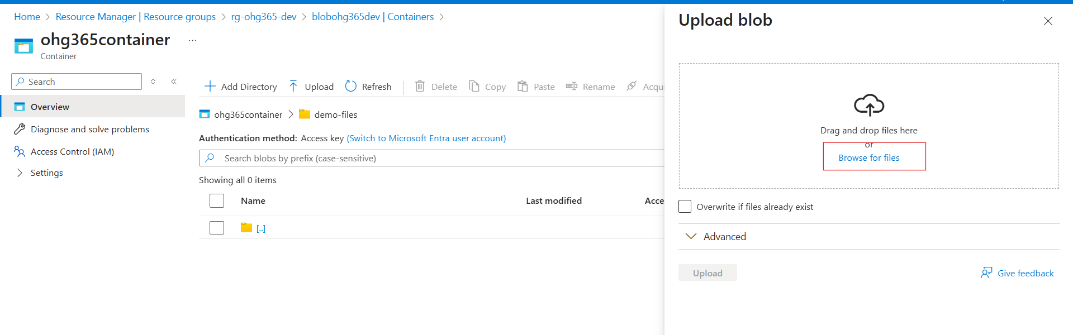

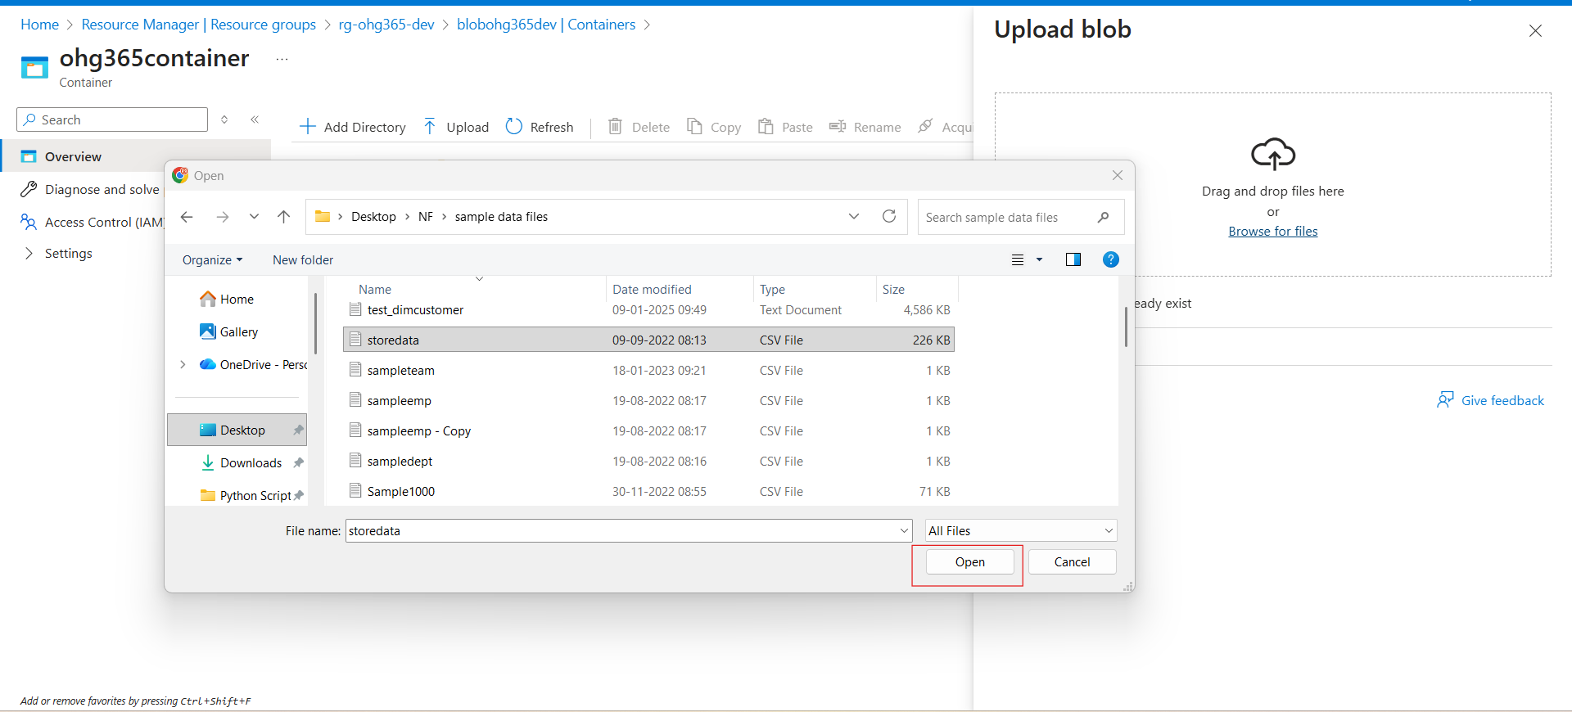

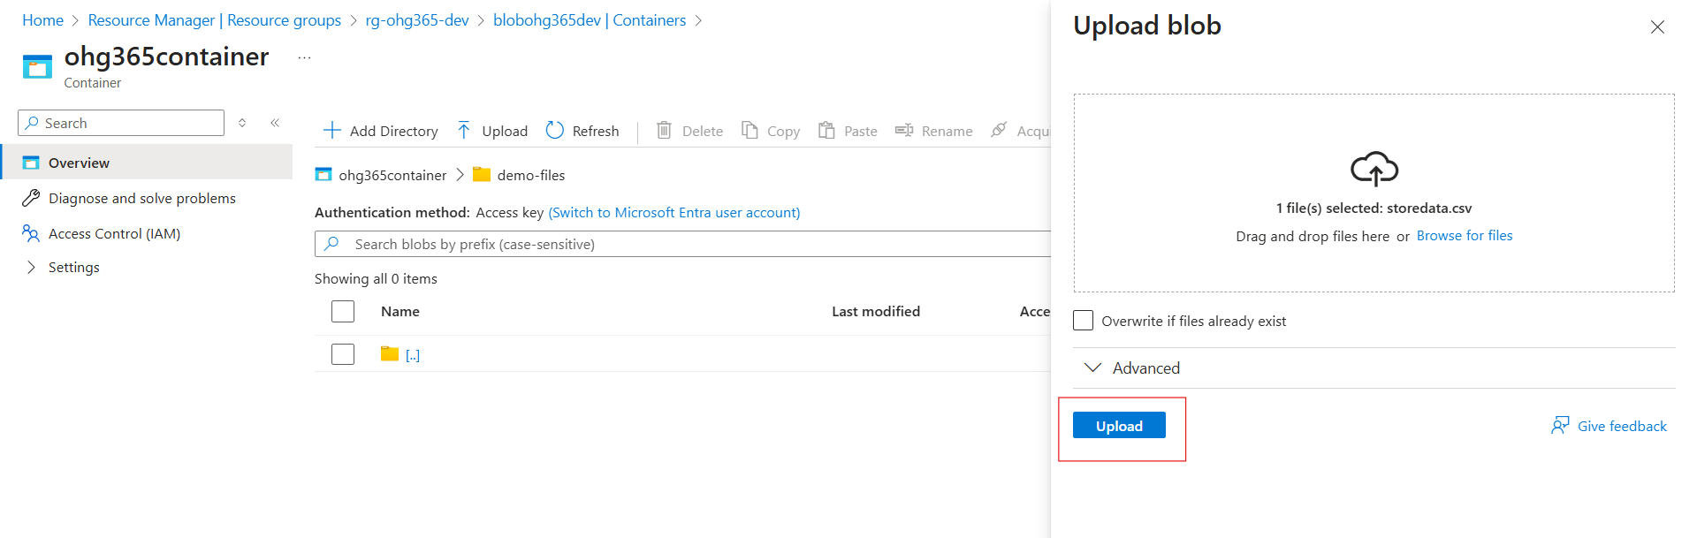
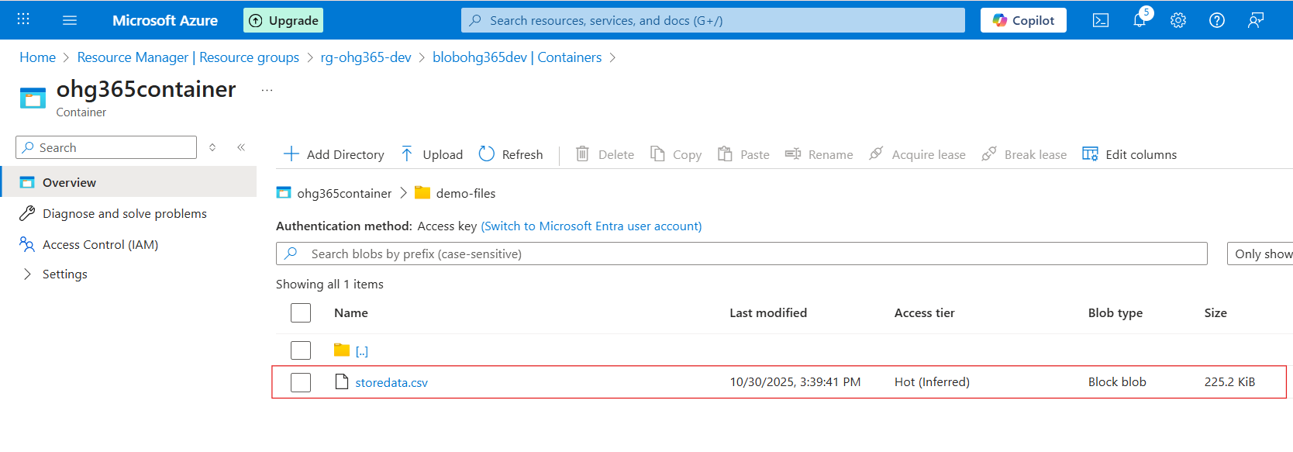
Types of Blob Types:
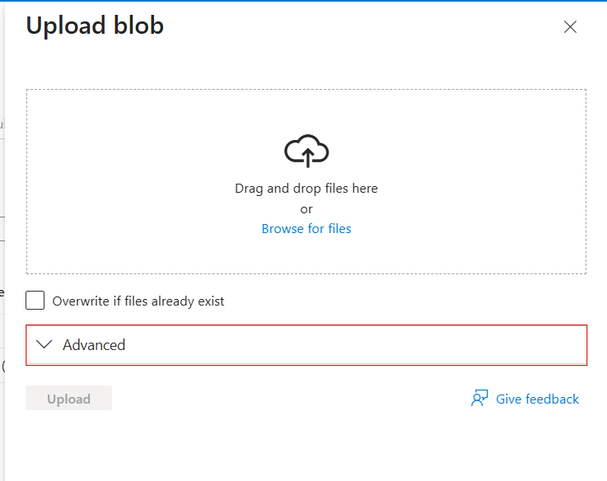

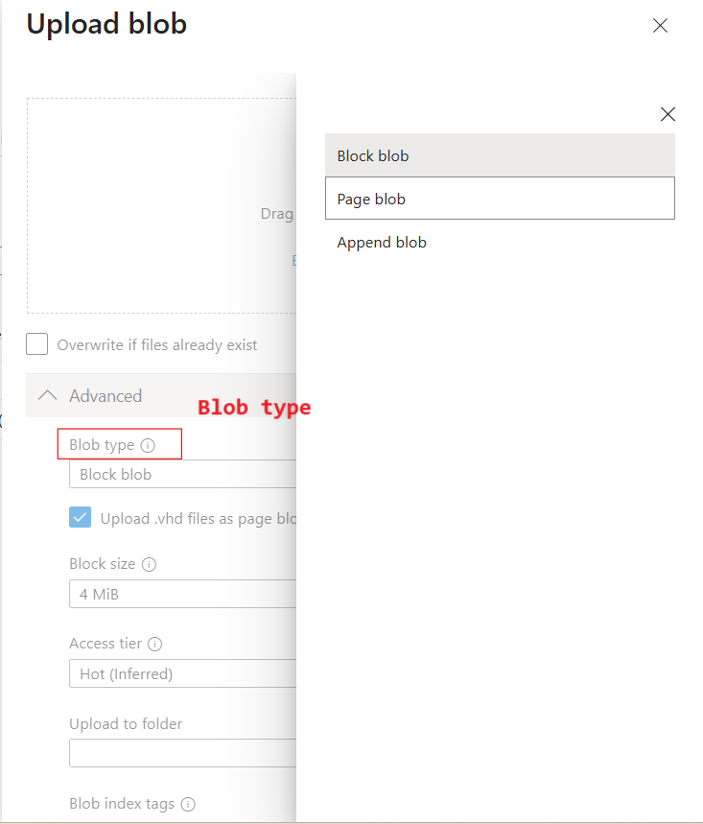

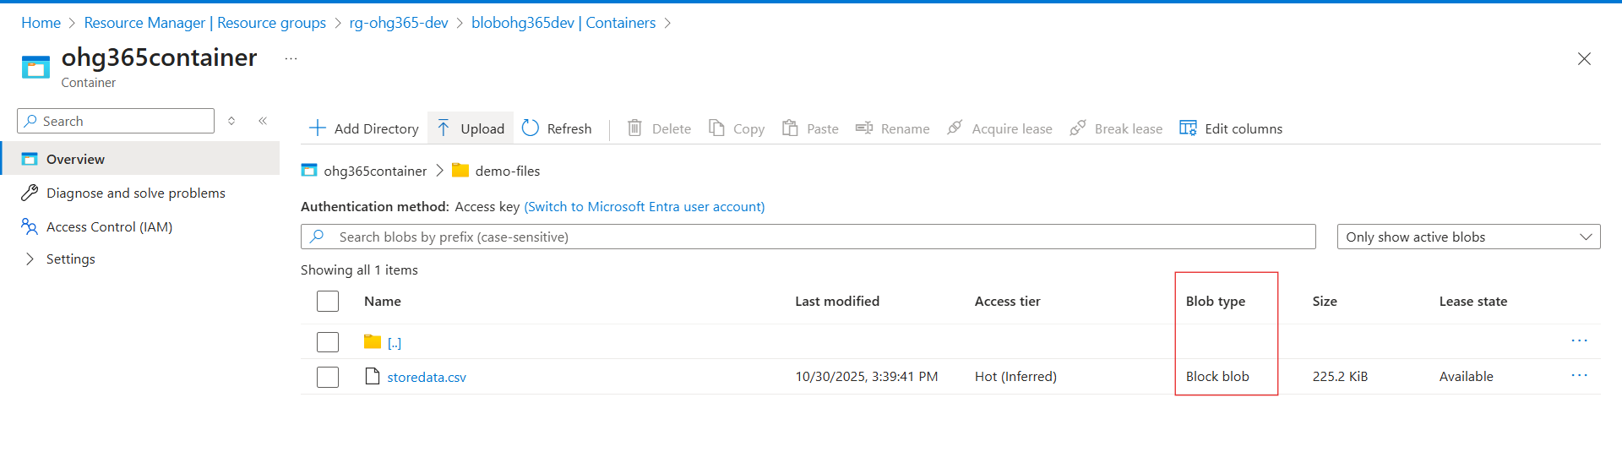

Blob Type | Best For | Example Use
🧱 Block Blob | Storing text or binary data | Images, videos, documents, CSVs
📜 Append Blob | Data that is constantly added to (append-only) | Logs, telemetry, audit data
📄 Page Blob | Random read/write access | Virtual machine disks (VHD files)

🧱 1. Block Blob
Most common blob type used in Azure.
💡 What it is:
- Stores text and binary data (files like .txt, .jpg, .mp4, .csv, etc.)
- Data is split into blocks, and each block is identified by a block ID.
- You can upload or update blocks individually and commit them together.
✅ Use Cases:
- Storing images, videos, PDFs, and backups.
- Data files for analytics (CSV, JSON, Parquet).
- Large files uploaded in chunks.
📘 Example:
You upload a 500 MB video file — Azure divides it into smaller blocks and uploads each part separately for speed and reliability.

📜 2. Append Blob
Special type of blob for data that grows over time.
💡 What it is:
- Optimized for append operations — you can only add new data to the end, not modify or delete existing data.
- Each time you add new information, it’s appended to the blob.
✅ Use Cases:
- Storing log files.
- Application telemetry or diagnostics data.
- Streaming data that’s constantly being added.
📘 Example:
You’re logging website visits. Each time a new visitor arrives, their data (timestamp, IP, etc.) is appended to the existing log file.

📄 3. Page Blob
Designed for random read/write operations.
💡 What it is:
- Data is stored in fixed-size 512-byte pages.
- Allows fast read and write access to specific parts of the blob.
- Commonly used for storing Virtual Hard Disk (VHD) files that power Azure Virtual Machines.
✅ Use Cases:
- Storing Azure VM disks (OS and data disks).
- Large databases that require random access.
- Any workload that reads/writes frequently to specific sections of a file.
📘 Example:
When you start an Azure Virtual Machine, its disk (a .vhd file) is stored as a Page Blob, allowing the VM to quickly read or write data anywhere on the disk.

Blob Type | Structure | Read/Write Behavior | Common Use
Block Blob | Data stored as blocks | Upload/replace blocks | Files, media, documents
Append Blob | Sequentially added blocks | Append-only | Logs, telemetry, streaming data
Page Blob | Fixed 512-byte pages | Random read/write | VM disks, large databases

Types of Access Tiers:
Azure lets you store data in different tiers based on how often you need it.
This helps save money 💰 by matching storage cost to usage.
Tier | Cost | Availability | Best For
Hot | 💰 Highest cost | 🔥 Always available | Frequently accessed data (e.g., active apps, websites)
Cool | 💸 Cheaper | 🕓 Slight delay in access | Infrequently accessed data (e.g., monthly reports)
Cold | 💧 Cheaper than Cool | ⏱️ Slower access | Rarely accessed data but still retrievable
Archive | 🧊 Cheapest | 💤 Retrieval takes hours | Long-term backups, compliance storage

